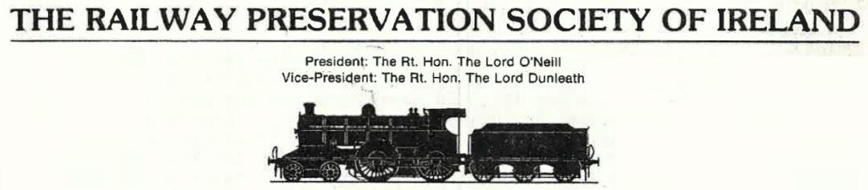

MARCH 1985 NEWS-SHEET

Eggstra, Eggstra It's Easter Bunny time at Whitehead folks! On Sunday and Monday April 7th & 8th there will be steam trips at Whitehead with a present for the children from the Easter Bunny and a glass of something warming for the parents. All terrific value with no advance booking needed - bring a friend. 2.00 p.m.-5.00 p.m.
Popping Down to Cork? If so, complete the enclosed booking form and send it with your cheque to Ernie Gilmore, 20 Chichester Road, Belfast AS SOON AS POSSIBLE TO BE SURE OF YOUR SEAT. With over 170 firm bookings already this one looks to be a sell-out.
Police Probe Police are investigating two recent break-ins at the RPSI's Whitehead site in which tools and equipment were removed by intruders. Security precautions at the site are under review.
Top of the Form An appeal from schools' day organiser J. Glendinning for assistance at Whitehead on 28/29 May. Around 1,000 children descending on the site. We need more people to man the admission desk, shop, diner and guides. Please contact Johnny or WRP, Whitehead 78567.
Merlin Takes Wing Some good news is that on St. Patrick's Day Ex-GNR(I) No.85 was steamed at Whitehead, and made some trips up and down the platform with Lord Dunleath at the regulator.
Last Waltz Due to lack of support the proposed RPSI 21st anniversary dinner dance was regrettably cancelled. In the end 45 people had sent bookings, but the figure needed to break even was 72. Apologies to those who did book, and thanks to the organisers. We may have another go at the end of 1985.
Top Brass On March 11th a delegation from the Society led by Chairman Sullivan Boomer met with the senior management of CIÉ to discuss the RPSI's plans for the future. It was a most constructive get-together and should bear fruit in the future.
Down Mullingar Way The embryonic Mullingar carriage and wagon department have been busying themselves with sorting out some coaches recently acquired from CIÉ. The intention is to base a second mainline train at Mullingar for use on such trips as the Claddagh railtour.
Riotous Assembly As those of you who study the local press may be aware, the Society made a submission to the education committee of the Northern Ireland Assembly concerning the proposal for a railway museum at Whitehead. Johnny Glendinning, John Friel, Ernie Gilmore and Raymond Leith unveiled both our proposals and a scale model of the intended site plan.
Manxman The Isle of Man Railway Society has asked us to inform members of the Isle of Man May Transport Weekend. Attractions include both Electric and Steam hauled railways, horse trams, film shows and Shed visits. May 25th-27th.
Diesel Tour Word from the Great Southern Railway Preservation Society of a Diesel Tour over CIÉ on Saturday April 6th. It's from Dun Laoghaire to Cobh. Details from David Parkes, Edermine, Kingsmill Road, Bray County Wicklow.
PSRs The following members have been appointed to posts of special responsibility within the Society:

Mervyn Darragh Membership Secretary
Brian Ham Legal Advisor
Derek Young Insurance Advisor
Charles Friel Belfast Area Meeting & Official Photographer.
Gavin Martin Assistant Editor and News-Sheet
Paddy O'Brien Mullingar Locomotive Maintenance
Alan Love Portrush Flyer
Tony Ragg Steam Enterprise
Denis McCabe Mullingar Coach Running
Colin Holliday Coach Running Assistant
Thomas Charters Carriage Maintenance Assistant and Safety
Training In Progress The Whitehead Railway Project continues at a cracking pace. Inside their shed at the site Ex-GSR side corridor 1335 is being prepared for an external repaint following the eradication of the dreaded tinworm from her vital parts. Also, Ex-LMS NCC 68, restored by the lads on the project will be shunted into the train for the two day tour sometime around Easter.
Fame Again Ulster Television are completing their film about Traen 150 and are planning a special filming sequence of ex-GNR(I) No.85 in steam at Whitehead.
Shaping The Landscape The Railway Clearing House Maps are proving really popular. These are really attractive maps copied from an actual example on the wall at the tarry at Whitehead. Only £2.50 from member H. Beaumont.
All Tied Up A new tie depicting the Ulster Transport Authority crest (Red Hand) joins the existing range of GNR(I), D&SER, B&CDR, GSR, MGWR & CDRJC. All priced at a mere £4! There is a possibility of producing an 85 tie and sweatshirt, watch this space for details!!!
-o0o-

